Treyton Davis

CS-405

May 11, 2024

Module One Assignment

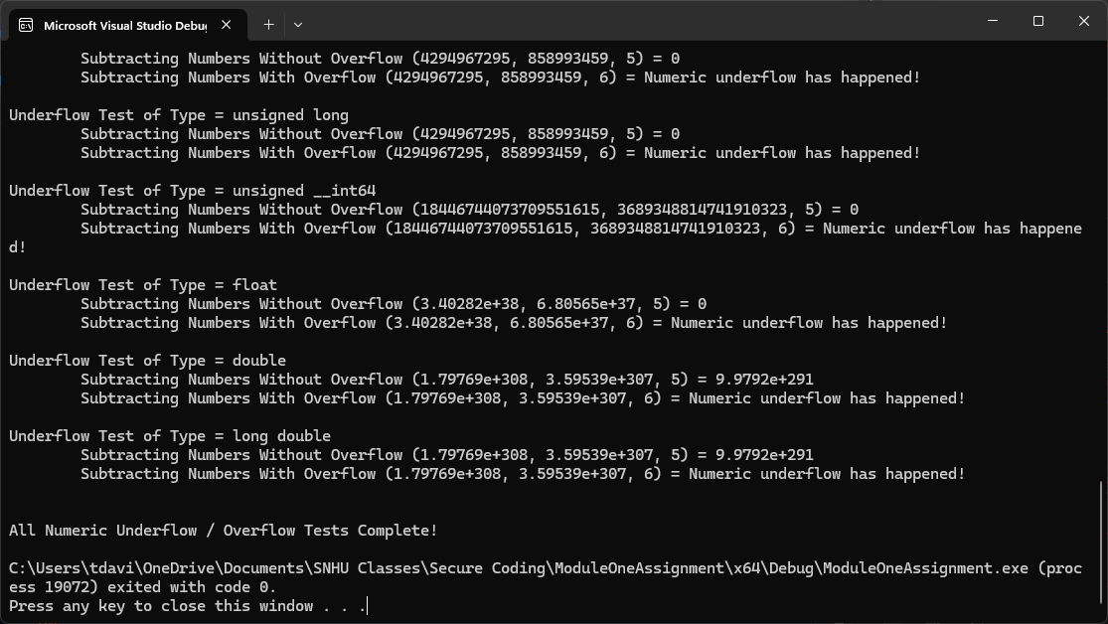

To ensure the detection of overflow or underflow errors in the system, I implemented an if/else-if block in the add_numbers and subtract_numbers functions. In the case of add_numbers, I checked if the increment was greater than or equal to 0 and if the result was greater than max + increment. If both conditions were true, an overflow was detected and handled accordingly. On the other hand, for underflow detection in add_numbers, I checked if the increment was less than 0 and if the result was less than min - increment. In the case of subtract_numbers, the process was reversed. If the decrement was less than 0 and the result was greater than max + decrement, an overflow was detected. Conversely, if the decrement was greater than or equal to 0 and the result was less than min + decrement, an underflow was detected.